PROJECT REPORT
ON
“AI HARD COPY EXAM EVALUATOR”
SUBMITTED IN PARTIAL FULFILLMENT OF THE REQUIREMENTS FOR THE AWARD OF THE DEGREE
DIPLOMA IN CSE/ARTIFICIAL INTELLIGENCE AND MACHINE LEARNING
By

MANTOL SAKETH (23054-AI-027)
SRIKHAR (B.TECH)
PUSA VAISHNAVI (23189-CS-189)
MUKKU MADHURI (23248-CS-177)

UNDER THE GUIDANCE OF
S. VAMSI
ML Engineer, Co-ordinator & Trainer at CITD



Department of Short-Term Training

Central Institute of Tool Design

Balanagar, Hyderabad-500011(T.S)
(2026)

DEPARTMENT OF CSE/ARTIFICIAL INTELLIGENCE AND
MACHINE LEARNING

CERTIFICATE

This is to certify that the project entitled “AI HARD COPY EXAM EVALUATOR” has been submitted by the following students:

- MANTOL SAKETH (23054-AI-027)
- SRIKHAR (B.TECH)
- PUSA VAISHNAVI (23189-CS-189)
- MUKKU MADHURI (23248-CS-177)

This project is hereby submitted as part of the industrial training requirements and has also been presented to the Central Institute of Tool Design (CITD). The results embodied in this project have not been submitted to any other institution for the award of any degree or diploma.

TRAINING GUIDE IN CHARGE
Mr. S. VAMSI Mrs CH. KASTURI

EXTERNAL EXAMINER

DEPARTMENT OF ARTIFICIAL INTELLIGENCE AND MACHINE LEARNING

DECLARATION

We hereby declare that the project entitled "AI HARD COPY EXAM EVALUATOR" submitted to the State Board of Technical Education and Training (SBTET), Hyderabad, in partial fulfillment of the requirements for the award of Diploma in Computer Science and Engineering, is a record of original work carried out by us under the guidance of Mr. S. Vamsi, Department of Computer Science and Engineering, Central Institute of Tool Design (CITD), Hyderabad.
We further declare that this project has not been submitted previously, either in full or in part, to any other institution or university for the award of any degree, diploma, or certificate.
The information, data, and results presented in this project report are genuine and have been developed as part of our academic project work. All sources of information used in the preparation of this report have been properly acknowledged and referenced.

MANTOL SAKETH (23054-AI-027)
SRIKHAR (B.TECH)
PUSA VAISHNAVI (23189-CS-189)
MUKKU MADHURI (23248-CS-177)

DEPARTMENT OF ARTIFICIAL INTELLIGENCE & MACHINE LEARNING

ACKNOWLEDGEMENT

The satisfaction and euphoria that accompany the successful completion of any task would be incomplete without the mention of those whose constant guidance and encouragement made it possible. We are grateful for their invaluable contributions, which have crowned our efforts with success.
First of all, we would like to express our deep gratitude to MR. S. VAMSHI, ML Engineer, Co-ordinator & Trainer at CITD, for his unwavering support throughout the course of our dissertation.
We also wish to extend our sincere thanks to Dr. G. ARUN MANOHAR, Head of Industrial Training Department at CITD, & Mrs. CH. KASTURI, Trainer & IN charge of Industry 4.0, for providing the facilities necessary for completing our dissertation.
We are indebted to all our faculty members and friends for their help and constructive criticism during the project period.
Finally, we express our heartfelt appreciation to our parents for their moral support and encouragement, without which this achievement would not have been possible.

MANTOL SAKETH (23054-AI-027)
SRIKHAR (B.TECH)
PUSA VAISHNAVI (23189-CS-189)
MUKKU MADHURI (23248-CS-177)

ABSTRACT
The AI Hard Copy Exam Evaluator is an intelligent examination evaluation platform designed to automate the assessment of handwritten answer sheets using Artificial Intelligence (AI), Optical Character Recognition (OCR), and Large Language Models (LLMs). Traditional answer sheet evaluation is a time-consuming and labor-intensive process that requires educators to manually read, analyze, and grade student responses. This project aims to reduce evaluation time, improve grading consistency, and assist teachers through intelligent automation.
The system accepts question papers and student answer sheets in the form of PDF documents, images, or compressed ZIP files. The uploaded answer sheets are processed using Pabbly OCR API, which extracts handwritten and printed text and converts it into machine-readable format. The extracted content is then analyzed by the NVIDIA Nemotron Nano 12B Multimodal Large Language Model, which performs document understanding, question-answer matching, semantic analysis, and automated evaluation.
The platform automatically extracts questions from the uploaded question paper, identifies corresponding student answers, evaluates responses based on conceptual understanding, and assigns marks according to the question requirements. In addition to marks allocation, the system generates detailed feedback, identifies strengths and weaknesses, and provides confidence scores indicating the reliability of AI-generated evaluations.
To ensure transparency and accuracy, the platform includes a teacher review module that allows educators to compare the original answer sheet with OCR-generated text, verify AI-assigned marks, and manually override scores whenever necessary. The system also generates comprehensive evaluation reports and performance analytics for students and examinations.
The backend of the system is developed using Python and FastAPI, while cloud infrastructure is managed using Amazon Web Services (AWS). AWS EC2 is used for hosting the application, AWS S3 is used for secure storage of documents and reports, and AWS IAM provides access control and security management.
The AI Hard Copy Exam Evaluator demonstrates the practical application of Artificial Intelligence in education by significantly reducing manual effort, accelerating result generation, and providing a scalable solution for modern examination systems. The project highlights how OCR technology, cloud computing, and advanced language models

CONTENTS
Chapter / Section | Contents | Page No.
- | Certificate | 2
- | Declaration | 3
- | Acknowledgement | 4
- | Abstract | 5
- | Table of Contents | 6-7
1 | INTRODUCTION | 8
1.1 | Overview of the Project | 8
1.2 | Importance of Automated Exam Evaluation | 9
1.3 | Key Features of the System | 10
1.4 | Purpose and Objectives | 11
1.5 | Scope of the Project | 12
2 | LITERATURE SURVEY | 13
2.1 | Existing Technologies and Tools | 13
2.2 | Research Studies on Automated Examination Evaluation | 14
2.3 | Challenges in Automated Answer Sheet Evaluation | 15
2.4 | Gaps Identified in Current Solutions | 16
3 | SYSTEM ANALYSIS | 17
3.1 | Requirements Analysis | 17
3.2 | Functional Requirements | 18
3.3 | Non-Functional Requirements | 19
3.4 | System Specifications | 20
4 | SYSTEM DESIGN | 21
4.1 | System Architecture | 21
4.2 | Input Design | 22
4.3 | Output Design | 23
4.4 | Database and Storage Design | 24
4.5 | Module Design | 25
5 | IMPLEMENTATION | 26
5.1 | Question Paper Upload and Processing | 26
5.2 | Answer Sheet Upload and OCR Processing | 27
5.3 | Document Understanding and Question Matching | 28
5.4 | AI Evaluation and Report Generation | 29
6 | APPLICATION DEPLOYMENT | 30
6.1 | Development Platform | 30
6.2 | Server Configuration | 31
6.3 | Network Requirements | 32
6.4 | Performance Optimization | 33
7 | APPENDICES | 34
7.1 | Program Codes | 34
7.2 | Application Screenshots | 40
8 | CONCLUSION | 43
8.1 | Summary of the Project | 43
8.2 | Achievements and Findings | 43
8.3 | Future Enhancements | 44
8.4 | Final Thoughts | 44
9 | REFERENCES | 45

CHAPTER-I
INTRODUCTION

1.1 Overview of the Project
The AI Hard Copy Exam Evaluator is an intelligent examination assessment system developed to automate the evaluation of handwritten answer sheets using Artificial Intelligence (AI), Optical Character Recognition (OCR), and Large Language Models (LLMs). Traditional examination evaluation requires teachers to manually read and grade answer sheets, which is time-consuming, labor-intensive, and prone to inconsistencies. The proposed system addresses these challenges by automating the complete evaluation workflow.
The platform accepts question papers and student answer sheets in various formats such as PDF documents, images, and ZIP files. Using Pabbly OCR API, handwritten content is extracted and converted into machine-readable text. The extracted information is then analyzed by the NVIDIA Nemotron Nano 12B Multimodal Large Language Model to understand questions, map corresponding answers, evaluate responses, and assign marks.
The system also generates feedback, confidence scores, performance reports, and analytics while providing teachers with the ability to review and manually override AI-generated evaluations whenever necessary. The project demonstrates how Artificial Intelligence can significantly improve efficiency, consistency, and scalability in educational assessment systems.
1.2 Importance of Fake News Detection
In modern educational institutions, evaluating large numbers of answer sheets manually is a challenging task. Teachers often spend considerable time reading answer scripts, assigning marks, and preparing reports. This process becomes even more difficult during semester examinations, entrance tests, and large-scale assessments involving hundreds or thousands of students.
Automated exam evaluation provides several benefits:
- Reduces the workload of teachers and evaluators.
- Minimizes human errors and inconsistencies in marking.
- Accelerates result generation.
- Provides objective and unbiased evaluation.
- Enables large-scale processing of answer sheets.
- Generates detailed performance reports and feedback.
- Improves transparency in the evaluation process.
With advancements in Artificial Intelligence and OCR technologies, it is now possible to accurately process handwritten answer sheets and evaluate responses based on conceptual understanding rather than simple keyword matching.
1.3 Key Features of the System
The AI Hard Copy Exam Evaluator includes several advanced features designed to simplify examination assessment.

Handwritten Answer Sheet Evaluation
The system can process handwritten answer sheets and automatically convert them into machine-readable text using OCR technology.

Question Paper Analysis
The platform extracts questions and marks allocation from uploaded question papers to create an evaluation blueprint.

AI-Based Evaluation
The NVIDIA Nemotron Nano 12B Multimodal LLM evaluates answers based on correctness, completeness, relevance, and conceptual understanding.

Question-Answer Matching
The system intelligently maps student answers to corresponding questions, even when answer numbering is inconsistent or missing.

Confidence Scoring
A confidence score is generated for every evaluation, helping teachers identify answers that may require manual review.

Teacher Review and Override
Teachers can compare original answer sheets with OCR-generated text, verify AI-assigned marks, and modify scores when necessary.

Report Generation
The platform automatically generates detailed evaluation reports containing marks, feedback, strengths, weaknesses, and performance analysis.

Cloud-Based Storage
AWS S3 is used to securely store answer sheets, question papers, OCR results, and generated reports.

Secure Access Management
AWS IAM provides secure authentication and access control for cloud resources.
1.4 Purpose and Objectives

Main Purpose
The primary purpose of the AI Hard Copy Exam Evaluator is to automate the evaluation of handwritten answer sheets while maintaining accuracy, consistency, and transparency in the assessment process.

Objectives
- To develop an intelligent system capable of evaluating handwritten answer sheets.
- To automate question extraction from uploaded question papers.
- To implement OCR-based text extraction from scanned answer sheets.
- To perform AI-driven answer evaluation using advanced language models.
- To generate confidence scores for evaluation reliability.
- To provide detailed feedback and performance reports.
- To reduce manual effort and evaluation time.
- To allow teacher review and manual override of AI-generated marks.
- To create a scalable cloud-based examination assessment platform.

1.5 Scope of the Project

In Scope
The project focuses on the following functionalities:
- Uploading question papers and answer sheets in PDF and image formats.
- Extracting handwritten text using OCR technology.
- Understanding question papers and student responses.
- Matching answers with corresponding questions.
- Evaluating answers using Artificial Intelligence.
- Generating marks, feedback, and confidence scores.
- Producing student performance reports.
- Providing teacher review and override functionality.
- Storing examination data securely using AWS cloud services.
- Supporting educational institutions in automating examination workflows.

Out of Scope
The following functionalities are not included in the current version of the project:
- Real-time online examination monitoring.
- Voice-based answer evaluation.
- Video-based examination assessment.
- Automatic evaluation of highly complex diagrams and mathematical derivations.
- Mobile application support.
- Integration with external university examination systems.

CHAPTER-II
LITERATURE SURVEY

2.1 Existing Technologies and Tools
Several technologies and tools have been developed to assist educational institutions in managing examinations and evaluating answer sheets. Traditional examination management systems primarily focus on storing student records and publishing results but lack intelligent answer evaluation capabilities.

Optical Character Recognition (OCR)
OCR technology converts handwritten or printed documents into machine-readable text. Modern OCR solutions such as Pabbly OCR, Google Vision OCR, and Tesseract OCR can extract information from scanned documents and images. OCR serves as the foundation for automated answer sheet evaluation systems.

Artificial Intelligence and Natural Language Processing
Natural Language Processing (NLP) enables computers to understand, analyze, and process human language. Recent advancements in Large Language Models (LLMs) have significantly improved the ability of machines to evaluate written content, understand context, and generate meaningful feedback.

Large Language Models (LLMs)
Large Language Models such as NVIDIA Nemotron, GPT, and LLaMA have demonstrated remarkable performance in text understanding, question answering, and semantic analysis. These models can assess conceptual correctness rather than relying solely on keyword matching.

Cloud Computing
Cloud platforms such as Amazon Web Services (AWS) provide scalable infrastructure for hosting applications, storing examination data, and managing system resources securely. Services like AWS EC2, S3, and IAM help build reliable and secure educational applications.

2.2 Research Studies on Misinformation Detection
Several researchers have explored the use of Artificial Intelligence and Machine Learning in educational assessment systems.
Early automated evaluation systems relied heavily on keyword matching techniques and predefined scoring rules. While these methods were effective for objective questions, they struggled to evaluate descriptive answers accurately.
Recent research focuses on applying Natural Language Processing and Deep Learning techniques to understand student responses more effectively. Studies have shown that transformer-based language models can analyze answer semantics, compare responses with expected solutions, and generate meaningful evaluation scores.
Research has also demonstrated that integrating OCR with AI models enables automated evaluation of handwritten answer sheets. Such systems significantly reduce evaluation time while maintaining acceptable levels of accuracy.
The emergence of Large Language Models has further improved automated assessment by allowing systems to evaluate answers based on conceptual understanding, logical reasoning, and completeness rather than exact textual matches.

2.3 Challenges in Multilingual Text Classification
Developing an automated answer sheet evaluation system presents several technical and practical challenges.

Handwriting Recognition
Students have different handwriting styles, making accurate OCR extraction difficult. Poor handwriting quality can lead to incorrect text extraction and evaluation errors.

Answer Structure Variations
Students often write answers in different formats, use alternative numbering schemes, or omit question numbers entirely. This creates challenges in correctly mapping answers to questions.

Semantic Understanding
Evaluating descriptive answers requires deep contextual understanding. Different students may express the same concept using different words, making traditional keyword-based evaluation insufficient.

OCR Errors
Handwritten answer sheets frequently produce OCR inaccuracies due to image quality, page orientation, or writing style. These errors can affect answer interpretation.

Fair Evaluation
Ensuring consistency and fairness across different answer styles remains a critical challenge. The evaluation system must focus on conceptual correctness rather than writing style or grammar.

Scalability
Educational institutions often process hundreds or thousands of answer sheets. The system must be capable of handling large-scale evaluations efficiently.

2.4 Gaps Identified in Current Solutions
Although several examination management and OCR-based systems exist, most current solutions have significant limitations.

Limited Support for Handwritten Answer Evaluation
Many systems are designed primarily for objective-type examinations and do not effectively evaluate handwritten descriptive answers.

Keyword-Based Assessment
Traditional automated grading systems depend heavily on keyword matching, often failing to recognize conceptually correct answers expressed in different ways.

Lack of Intelligent Question Matching
Existing systems frequently assume that answers follow a fixed numbering format. They struggle when students omit question numbers or use inconsistent answer structures.

Absence of Confidence Scoring
Most evaluation systems provide marks without indicating the reliability of the assessment. Teachers have no way of identifying evaluations that may require manual review.

Limited Teacher Control
Many automated systems do not allow teachers to verify AI-generated evaluations or manually modify marks when required.

Inadequate Feedback Generation
Existing systems typically focus only on marks allocation and fail to provide meaningful feedback regarding strengths, weaknesses, and improvement areas.

Lack of Integrated Cloud-Based Workflow
Many solutions lack a complete workflow that combines OCR, document understanding, AI evaluation, report generation, analytics, and cloud storage within a single platform.
The AI Hard Copy Exam Evaluator addresses these limitations by integrating OCR technology, document understanding, intelligent question-answer matching, AI-based evaluation, confidence scoring, teacher review, and cloud-based storage into a unified and scalable examination assessment platform.

CHAPTER-III
SYSTEM ANALYSIS

3.1 Requirements Analysis
The AI Hard Copy Exam Evaluator is designed to automate the evaluation of handwritten answer sheets using Artificial Intelligence, OCR, and cloud technologies. The successful implementation of the system requires both hardware and software resources.

Hardware Requirements
- Processor: Intel Core i5 or higher.
- RAM: Minimum 8 GB (16 GB Recommended).
- Storage: Minimum 20 GB free disk space.
- Internet Connection: Required for cloud services, OCR processing, and AI model access.
- Scanner/Camera: For digitizing answer sheets and question papers.

Software Requirements
- Operating System: Windows, Linux, or macOS.
- Python 3.10 or above.
- FastAPI Framework.
- Pabbly OCR API.
- NVIDIA Nemotron Nano 12B Multimodal LLM.
- AWS EC2.
- AWS S3.
- AWS IAM.
- HTML, CSS, and JavaScript.
- Modern Web Browser (Chrome, Firefox, Edge).
The system is designed to provide efficient answer sheet evaluation while ensuring scalability, reliability, and security.
3.2 Functional Requirements
Functional requirements define the core operations performed by the system.

Question Paper Upload
The system must allow teachers to upload question papers in PDF or image formats.

Answer Sheet Upload
The system must support uploading answer sheets as PDF documents, images, or ZIP archives containing multiple answer sheets.

OCR Processing
The system must extract handwritten and printed text from uploaded answer sheets using OCR technology.

Question Extraction
The system must automatically identify questions and marks allocation from uploaded question papers.

Student Identification
The system should detect and extract student information such as name and roll number whenever available.

Question-Answer Matching
The system must map student answers to corresponding questions using intelligent matching techniques.

AI Evaluation
The system should evaluate answers using the NVIDIA Nemotron Nano 12B Multimodal Large Language Model.

Confidence Scoring
The platform must generate confidence scores for every evaluated answer.

Teacher Review
Teachers must be able to review OCR text, AI-generated marks, and manually override evaluation results.

Report Generation
The system should generate detailed evaluation reports and downloadable PDF documents.

Result Storage
The system must store evaluation records securely for future retrieval and analysis.

3.3 Non-Functional Requirements
Non-functional requirements define the quality and performance characteristics of the system.

Performance
The system should process and evaluate answer sheets within a reasonable time frame while maintaining accuracy.

Accuracy
OCR extraction and AI evaluation should provide reliable and consistent results.

Scalability
The platform should support processing large volumes of answer sheets from multiple examinations.

Reliability
The system should remain operational and provide consistent performance even during heavy workloads.

Security
AWS IAM should be used to manage permissions and secure access to cloud resources.

Availability
The application should be accessible whenever required by teachers and administrators.

Usability
The user interface should be simple, intuitive, and easy to operate.

Maintainability
The software architecture should support future enhancements and updates.

Portability
The system should function across multiple operating systems and web browsers.

Cloud Compatibility
The platform should integrate seamlessly with AWS services for hosting and storage.

3.4 System Specifications

Technology Stack
S.No | Layer | Technology
1 | Frontend | HTML5, CSS3, JavaScript
2 | Backend | Python, FastAPI, Uvicorn
3 | OCR Engine | Pabbly OCR API
4 | AI Evaluation Engine | NVIDIA Nemotron Nano 12B Multimodal LLM
5 | Cloud Hosting | AWS EC2
6 | Cloud Storage | AWS S3
7 | Security & Access Control | AWS IAM
8 | API Communication | REST API
9 | Document Processing | PDF, JPG, PNG, ZIP
10 | Report Generation | PDF Reports

System Components

Presentation Layer
Provides the web interface for teachers to upload question papers, answer sheets, review results, and generate reports.

Business Logic Layer
Handles OCR processing, document understanding, question matching, answer evaluation, confidence scoring, and report generation.

AI Processing Layer
Uses the NVIDIA Nemotron Nano 12B Multimodal LLM to perform semantic understanding, evaluation, and feedback generation.

Storage Layer
Stores uploaded files, OCR outputs, evaluation reports, and examination records using AWS S3.

Security Layer
Implements secure access control and permission management using AWS IAM.

CHAPTER-IV

SYSTEM DESIGN

4.1 System Architecture
The AI Hard Copy Exam Evaluator follows a modular architecture consisting of multiple interconnected components responsible for document processing, artificial intelligence evaluation, report generation, and cloud storage management.
The overall architecture begins with the teacher uploading a question paper and student answer sheets through the web interface. The uploaded documents are processed using the OCR engine, which extracts text from handwritten and printed content. The extracted text is then passed to the Document Understanding Module, where student details and answer sections are identified.
The Question Extraction Module processes the question paper and creates a structured blueprint containing question numbers, descriptions, and marks allocation. The Question Matching Module maps student answers to corresponding questions. The NVIDIA Nemotron Nano 12B Multimodal LLM evaluates the answers, assigns marks, generates feedback, and calculates confidence scores.
Finally, reports are generated and stored securely in AWS S3, while AWS IAM manages security and access permissions.

System Architecture Flow
Teacher
↓
Question Paper Upload
↓
Answer Sheet Upload
↓
OCR Processing (Pabbly OCR)
↓
Document Understanding
↓
Question Extraction
↓
Question Matching
↓
AI Evaluation (NVIDIA Nemotron Nano 12B)
↓
Confidence Scoring
↓
Report Generation
↓
AWS S3 Storage
↓
Teacher Review & Result Publication

4.2 Input Design
Input design focuses on collecting accurate information from users and documents for processing.

Question Paper Input
Teachers upload question papers in:
- PDF Format
- JPG Format
- PNG Format
The system extracts:
- Question Numbers
- Question Text
- Marks Allocation

Answer Sheet Input
Students' answer sheets can be uploaded as:
- PDF Files
- Scanned Images
- ZIP Archives containing multiple answer sheets
The OCR engine extracts:
- Student Information
- Handwritten Answers
- Page Content

User Inputs
The system also collects:
- Teacher Login Credentials
- Exam Information
- Subject Details
- Evaluation Preferences
Proper validation mechanisms ensure that only supported file formats and valid data are accepted.

4.3 Output Design
Output design focuses on presenting evaluation results in a clear and meaningful manner.

Evaluation Results
The system generates:
- Total Marks
- Question-wise Marks
- Confidence Scores
- Strengths
- Weaknesses
- Feedback

Student Report
Each student receives a detailed report containing:
- Student Information
- Exam Information
- Marks Obtained
- AI Feedback
- Performance Analysis

Teacher Dashboard
The dashboard displays:
- Number of Evaluated Sheets
- Pending Evaluations
- Average Marks
- Highest Score
- Lowest Score

Downloadable Reports
Reports can be generated in PDF format for future reference and record keeping.

4.4 Database and Storage Design
The project utilizes cloud storage architecture to manage documents and generated reports efficiently.

AWS S3 Storage Structure
question-papers/
answer-sheets/
ocr-results/
processed-files/
evaluation-reports/
analytics-reports/

Stored Information
The storage system maintains:
- Uploaded Question Papers
- Uploaded Answer Sheets
- OCR Generated Files
- Evaluation Results
- Generated Reports
- Analytics Data

Benefits
- Secure Storage
- Scalability
- High Availability
- Reliable Backup Management
AWS S3 ensures efficient management of examination-related data while supporting future expansion.

4.5 Module Design
The system is divided into several functional modules, each responsible for a specific task.

Authentication Module
Responsible for:
- User Login
- Access Verification
- Session Management

OCR Processing Module
Responsible for:
- Handwritten Text Recognition
- PDF Processing
- Image Processing
- OCR Text Extraction
Technology Used:
- Pabbly OCR API

Question Extraction Module
Responsible for:
- Extracting Questions
- Identifying Marks Allocation
- Creating Question Blueprints

Document Understanding Module
Responsible for:
- Student Information Detection
- Answer Segmentation
- Structured Data Generation

Question Matching Module
Responsible for:
- Mapping Answers to Questions
- Handling Missing Question Numbers
- Semantic Matching

Evaluation Module
Responsible for:
- Answer Analysis
- Marks Allocation
- Feedback Generation
- Confidence Calculation
Technology Used:
- NVIDIA Nemotron Nano 12B Multimodal LLM

Report Generation Module
Responsible for:
- Student Reports
- Evaluation Reports
- Performance Summaries

Storage Module
Responsible for:
- File Storage
- Report Storage
- Document Management
Technology Used:
- AWS S3
The modular design improves maintainability, scalability, and overall system performance while enabling future enhancements without affecting existing functionalities.

CHAPTER-V
IMPLEMENTATION

5.1 Question Paper Upload and Processing
The evaluation process begins when the teacher uploads the question paper through the web application. The question paper can be uploaded in PDF, JPG, JPEG, or PNG format. Once uploaded, the system extracts the text content and identifies the examination questions along with their corresponding marks allocation.
The extracted information is converted into a structured format that acts as the blueprint for evaluation. This blueprint contains question numbers, question descriptions, and maximum marks assigned to each question. The extracted questions are stored and used throughout the evaluation process to ensure accurate answer assessment.

5.2 Answer Sheet Upload and OCR Processing
After uploading the question paper, the teacher uploads student answer sheets. The platform supports single images, PDF documents, and ZIP files containing multiple answer sheets.
The uploaded answer sheets are processed using the Pabbly OCR API. The OCR engine converts handwritten content into machine-readable text by analyzing scanned images and document pages. The extracted content is then organized into structured JSON format for further processing.
The OCR module performs the following operations:
• Document Validation
• Image Processing
• Text Extraction
• OCR Data Structuring
• JSON Generation
The generated OCR output serves as the foundation for document understanding and answer evaluation.

5.3 Document Understanding and Question Matching
The extracted OCR text is analyzed by the Document Understanding Module. This module identifies important information such as student name, roll number, answer sections, and question references.
Since students often use different answer formats and numbering styles, the system employs intelligent question matching techniques. The module compares extracted answers with the question paper blueprint and maps each answer to its corresponding question.
The Question Matching Module is responsible for:
• Identifying answer boundaries
• Detecting question references
• Handling missing question numbers
• Managing OCR inconsistencies
• Matching answers semantically
This process ensures that each student response is evaluated against the correct question.

5.4 AI Evaluation and Report Generation
Once answers are successfully matched to their respective questions, the evaluation process is performed using the NVIDIA Nemotron Nano 12B Multimodal Large Language Model.
The AI model analyzes each answer based on:
• Correctness
• Concept Understanding
• Completeness
• Relevance
• Quality of Explanation
The evaluation engine generates:
• Marks Obtained
• Feedback
• Strengths
• Weaknesses
• Confidence Scores
After evaluation, detailed reports are generated for each student. These reports contain question-wise marks, overall performance, feedback, and confidence levels. The reports are securely stored in AWS S3 and can be reviewed by teachers through the application dashboard.
Teachers are also provided with manual override functionality, allowing them to verify AI-generated evaluations and modify marks whenever necessary. This combination of Artificial Intelligence and human supervision ensures both efficiency and reliability in the examination assessment process.

CHAPTER-VI
APPLICATION DEPLOYMENT

6.1 Development Platform
The AI Hard Copy Exam Evaluator was developed using modern web technologies, Artificial Intelligence frameworks, and cloud computing services. The development environment was selected to ensure scalability, maintainability, and efficient processing of examination data.

Development Tools Used
• Python Programming Language
• FastAPI Framework
• Uvicorn Server
• HTML5
• CSS3
• JavaScript
• Git and GitHub

AI and OCR Technologies
• Pabbly OCR API
• NVIDIA Nemotron Nano 12B Multimodal Large Language Model

Cloud Technologies
• AWS EC2
• AWS S3
• AWS IAM
The selected development platform provides flexibility for future enhancements and supports efficient integration of Artificial Intelligence and cloud services.

6.2 Server Configuration
The backend services of the system are hosted on AWS EC2 instances and managed through FastAPI and Uvicorn. The server is responsible for handling user requests, document processing, OCR operations, AI evaluation, and report generation.

Server Specifications
Processor : Intel Core i5 / Equivalent Cloud Instance
Memory : Minimum 8 GB RAM
Storage : 20 GB or Higher
Operating System : Linux / Windows
Web Framework : FastAPI
Application Server : Uvicorn
Cloud Hosting : AWS EC2

Server Responsibilities
• Handling API Requests
• OCR Processing
• Question Extraction
• Answer Evaluation
• Report Generation
• File Management
The server architecture is designed to support concurrent users and large-scale examination processing.

6.3 Network Requirements
The AI Hard Copy Exam Evaluator relies on internet connectivity for communication between the client application, OCR services, AI evaluation engine, and cloud storage infrastructure.

Network Requirements
Internet Connection : Broadband Connection
Minimum Speed : 10 Mbps
Recommended Speed : 50 Mbps or Higher
Protocol : HTTPS
Cloud Access : AWS Services
API Communication : REST APIs

Network Functions
• Uploading Question Papers
• Uploading Answer Sheets
• OCR Processing Requests
• AI Evaluation Requests
• Cloud Storage Access
• Report Downloads
A stable network connection is essential for uninterrupted document processing and evaluation operations.

6.4 Performance Optimization
Performance optimization plays a critical role in ensuring that the system can efficiently process large numbers of answer sheets within a short period.
Several optimization techniques were implemented during development.

Efficient OCR Processing
Answer sheets are processed page by page to reduce memory consumption and improve processing efficiency.

Structured Data Storage
OCR outputs and evaluation results are stored in structured formats to enable faster retrieval and report generation.

Cloud Storage Optimization
AWS S3 is used to store documents and generated reports, reducing server storage overhead and improving scalability.

API-Based Architecture
FastAPI provides asynchronous request handling, allowing multiple evaluations to be processed simultaneously.

Intelligent Question Matching
Semantic matching techniques reduce evaluation errors and improve answer mapping accuracy.

Scalable Infrastructure
AWS cloud resources allow the platform to handle increasing workloads without significant performance degradation.

Benefits of Optimization
• Faster Evaluation
• Reduced Processing Time
• Improved Scalability
• Better Resource Utilization
• Enhanced User Experience

CHAPTER-VII
APPENDICES

7.1 All Codes of The Project
backend/
│
├── app/
│ ├── main.py
│ │
│ ├── routes/
│ │ └── ocr.py
│ │
│ ├── services/
│ │ ├── pdf_service.py
│ │ ├── preprocess_service.py
│ │ ├── vision_service.py
│ │ ├── segmentation_service.py
│ │ └── json_builder.py
│ │
│ ├── utils/
│ │ ├── image_utils.py
│ │ └── regex_utils.py
│ │
│ ├── models/
│ │ └── schemas.py
│ │
│ └── storage/
│ ├── uploads/
│ ├── processed/
│ └── json/
│
├── requirements.txt
└── .env
main.py
from pathlib import Path
from fastapi import FastAPI from fastapi.middleware.cors import CORSMiddleware from fastapi.responses import FileResponse from fastapi.staticfiles import StaticFiles
from app.routes.ocr import router as ocr_router from app.routes.document import router as document_router from app.routes.evaluation import ( router as evaluation_router ) from app.routes.question_paper import ( router as question_paper_router )
FRONTEND_DIR = Path(file).resolve().parents[2] / "frontend"
app = FastAPI( title="Hard Copy Exam Evaluator", version="2.0.0" )
app.mount("/static", StaticFiles(directory=FRONTEND_DIR), name="static")

=========================================

CORS

=========================================
app.add_middleware( CORSMiddleware, allow_origins=[""], allow_credentials=True, allow_methods=[""], allow_headers=["*"], )

=========================================

ROUTES

=========================================
app.include_router( ocr_router, tags=["OCR"] )
app.include_router( document_router, tags=["Document Agent"] ) app.include_router( evaluation_router, tags=["Evaluation"] ) app.include_router( question_paper_router, tags=["Question Paper"] )

=========================================

ROOT

=========================================
@app.get("/") def root():
return {
"status": "running",
"project": "Hard Copy Exam Evaluator"
}
@app.get("/ui") def ui():
return FileResponse(FRONTEND_DIR / "index.html")

=========================================

HEALTH

=========================================
@app.get("/health") def health():
return {
"status": "healthy"
}
evaluation agent.py
import os import json
from groq import Groq from dotenv import load_dotenv

=========================================

ENV

=========================================
load_dotenv()
client = Groq( api_key=os.getenv("GROQ_API_KEY") )
MODEL_NAME = os.getenv( "EVALUATION_MODEL", "llama-3.3-70b-versatile" )

=========================================

EVALUATE ANSWERS

=========================================
def evaluate_exam(document_json):
try:
answers = document_json.get(
"answers",
[]
)
prompt = f"""
You are an expert examiner.
Evaluate the student's answers.
IMPORTANT RULES:
- Ignore spelling mistakes.
- Ignore grammar mistakes.
- Ignore OCR errors.
- Focus only on conceptual understanding.
- Focus only on correctness.
- Be lenient towards handwriting OCR mistakes.
- Award marks fairly.
For every answer return:
- question_no
- marks_awarded
- max_marks
- strengths
- weaknesses
- feedback
Return ONLY JSON.
FORMAT:
{{ "total_marks": 0, "obtained_marks": 0, "percentage": 0, "overall_feedback": "", "results": [ {{ "question_no": "", "marks_awarded": 0, "max_marks": 10, "strengths": [], "weaknesses": [], "feedback": "" }} ] }}
STUDENT ANSWERS:
{json.dumps(answers, indent=2)} """
response = client.chat.completions.create(
model=MODEL_NAME,
messages=[
{
"role": "user",
"content": prompt
}
],
temperature=0.2,
response_format={
"type": "json_object"
}
)
content = (
response
.choices[0]
.message
.content
)
return json.loads(content)
except Exception as e:
raise Exception(
f"Evaluation failed: {str(e)}"
)
question_paper_agent.py
import os import json
from groq import Groq from dotenv import load_dotenv

=========================================

LOAD ENV

=========================================
load_dotenv()

=========================================

GROQ CLIENT

=========================================
client = Groq( api_key=os.getenv("GROQ_API_KEY") )
MODEL_NAME = os.getenv( "DOCUMENT_MODEL", "llama-3.3-70b-versatile" )

=========================================

QUESTION PAPER AGENT

=========================================
def extract_question_paper(ocr_json):
try:
pages = ocr_json.get(
"pages",
[]
)
full_text = ""
for page in pages:
page_no = page.get(
"page_no",
0
)
page_text = page.get(
"text",
""
)
full_text += f"""

==================== PAGE {page_no}
{page_text}
"""
prompt = f"""
You are an expert Question Paper Extraction Agent.
The OCR text below comes from an examination question paper.
TASKS:
- Extract exam title.
- Extract subject name.
- Extract total marks.
- Extract duration if available.
- Detect sections (Section A, Section B, Part A, Part B, etc.).
- Extract every question.
- Extract exact marks mentioned for each question.
- Preserve question numbering.
- Normalize question numbering:
Q1 Q2 Q3
- Do NOT invent marks.
- If marks are not present return null.
- Ignore OCR errors and formatting issues.
- Return ONLY valid JSON.
OUTPUT FORMAT:
{{ "exam_title": "", "subject": "", "total_marks": null, "duration": "", "sections": [ {{ "section_name": "", "questions": [ {{ "question_no": "Q1", "question_text": "", "max_marks": null }} ] }} ] }}
OCR TEXT:
{full_text}
Return ONLY JSON. """
response = client.chat.completions.create(
model=MODEL_NAME,
messages=[
{
"role": "user",
"content": prompt
}
],
temperature=0.1,
response_format={
"type": "json_object"
}
)
content = (
response
.choices[0]
.message
.content
)
result = json.loads(
content
)
return result
except Exception as e:
raise Exception(
f"Question paper extraction failed: {str(e)}"
)
GitHub Repository
AI Hard Copy Exam Evaluator
Source Code:
https://github.com/your-username/ai-hardcopy-exam-evaluator



Scan the QR Code to access the complete project source code, documentation, and implementation details.
7.2 APPLICATION SCREENSHOTS

7.2 Output Screens
The AI Hard Copy Exam Evaluator generates various output screens that enable teachers to monitor examinations, review evaluations, and analyze student performance efficiently.

Dashboard Output
The dashboard provides an overview of the entire examination system. It displays key statistics such as the total number of examinations, registered students, evaluated answer sheets, and pending evaluations. Teachers can also access recent examinations and evaluation activities from the dashboard.
Output:
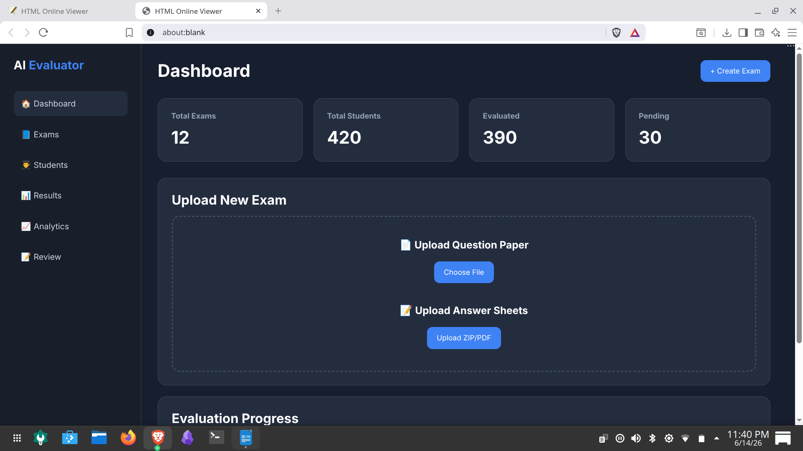

Question Paper Processing Output
After uploading a question paper, the system extracts questions and marks allocation automatically. The extracted information is displayed in a structured format for verification before evaluation begins.
The output contains:
• Question Number
• Question Description
• Maximum Marks
• Exam Information
Output:
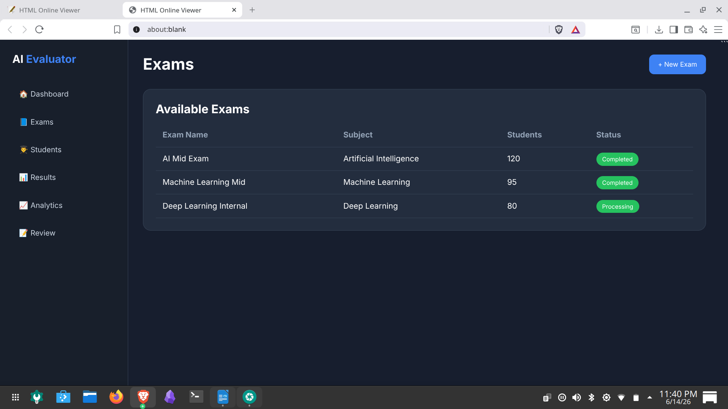

Evaluation Results Output
The AI Evaluation Module generates question-wise marks and overall scores based on the student's answers.
The output contains:
• Marks Obtained
• Maximum Marks
• Question-wise Evaluation
• Confidence Scores
• AI Feedback
Output:
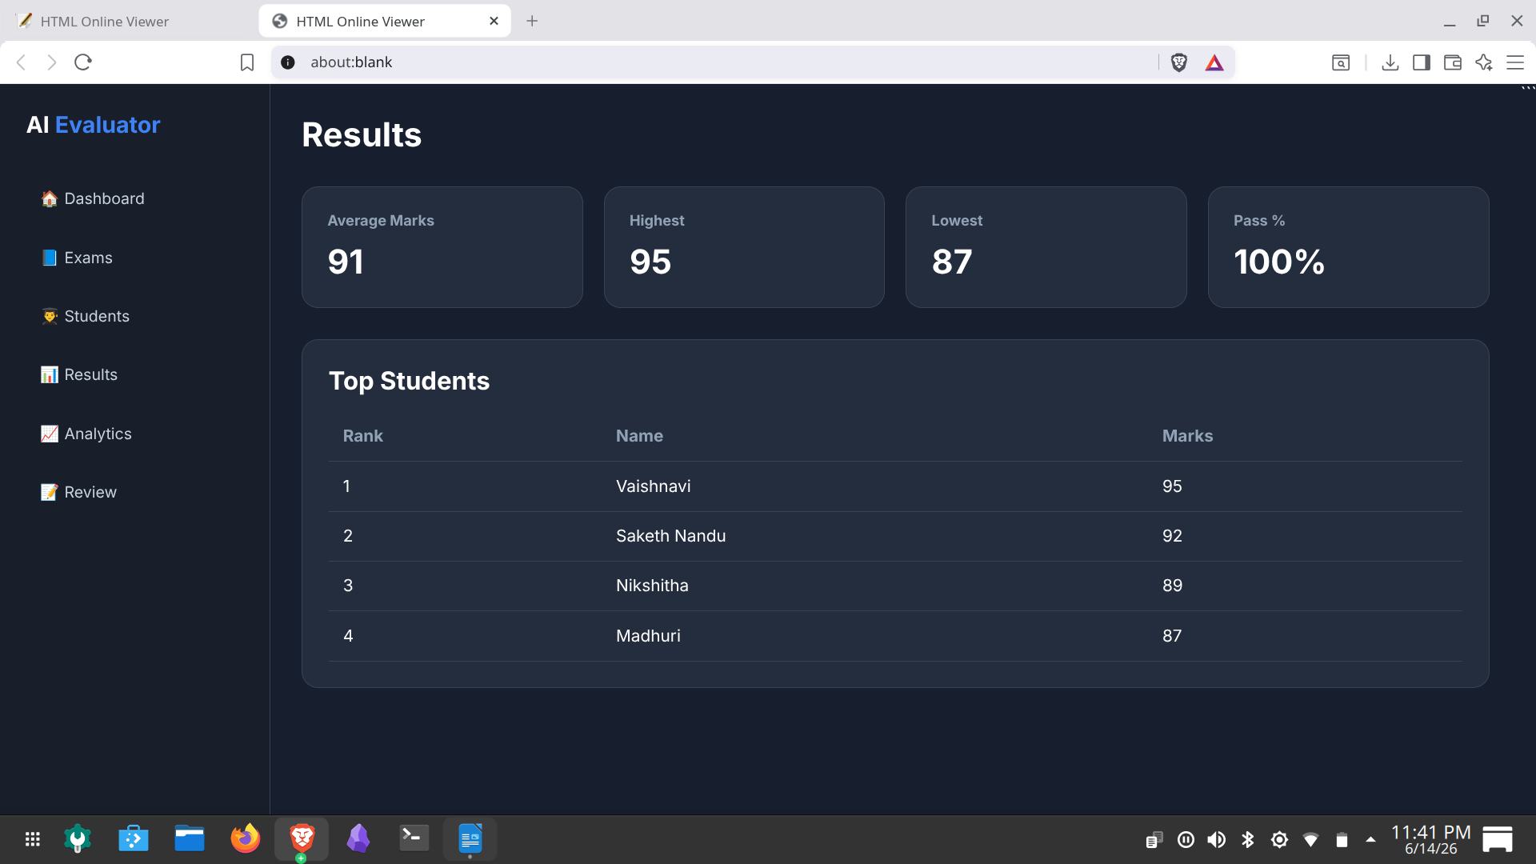

Student Performance Report Output
A detailed report is generated for every student after evaluation.
The report includes:
• Student Name
• Roll Number
• Exam Name
• Total Marks
• Question-wise Marks
• Strengths
• Weaknesses
• Improvement Suggestions
Output:
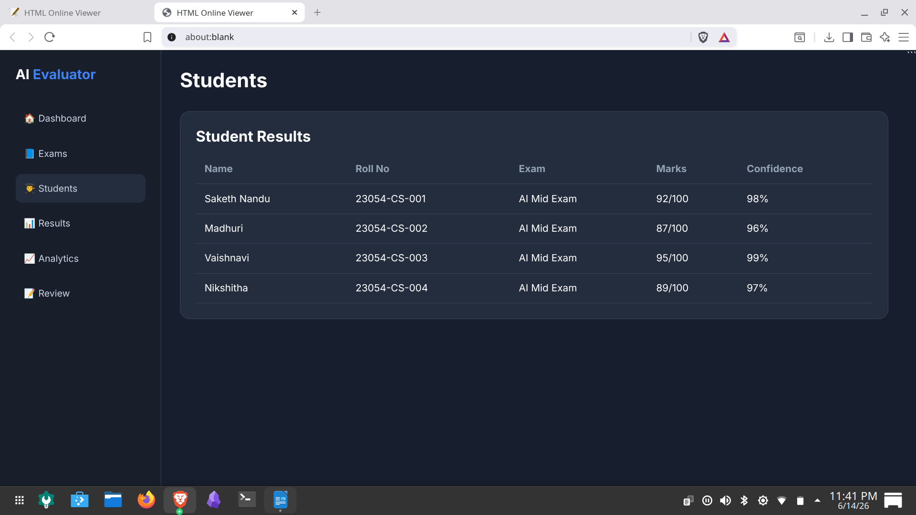

Teacher Review Output
The review module enables teachers to compare the original answer sheet with OCR-generated text and AI evaluation results.
The output displays:
• Original Answer Sheet
• OCR Extracted Text
• AI Allocated Marks
• Teacher Override Option
• Feedback Section
Output:
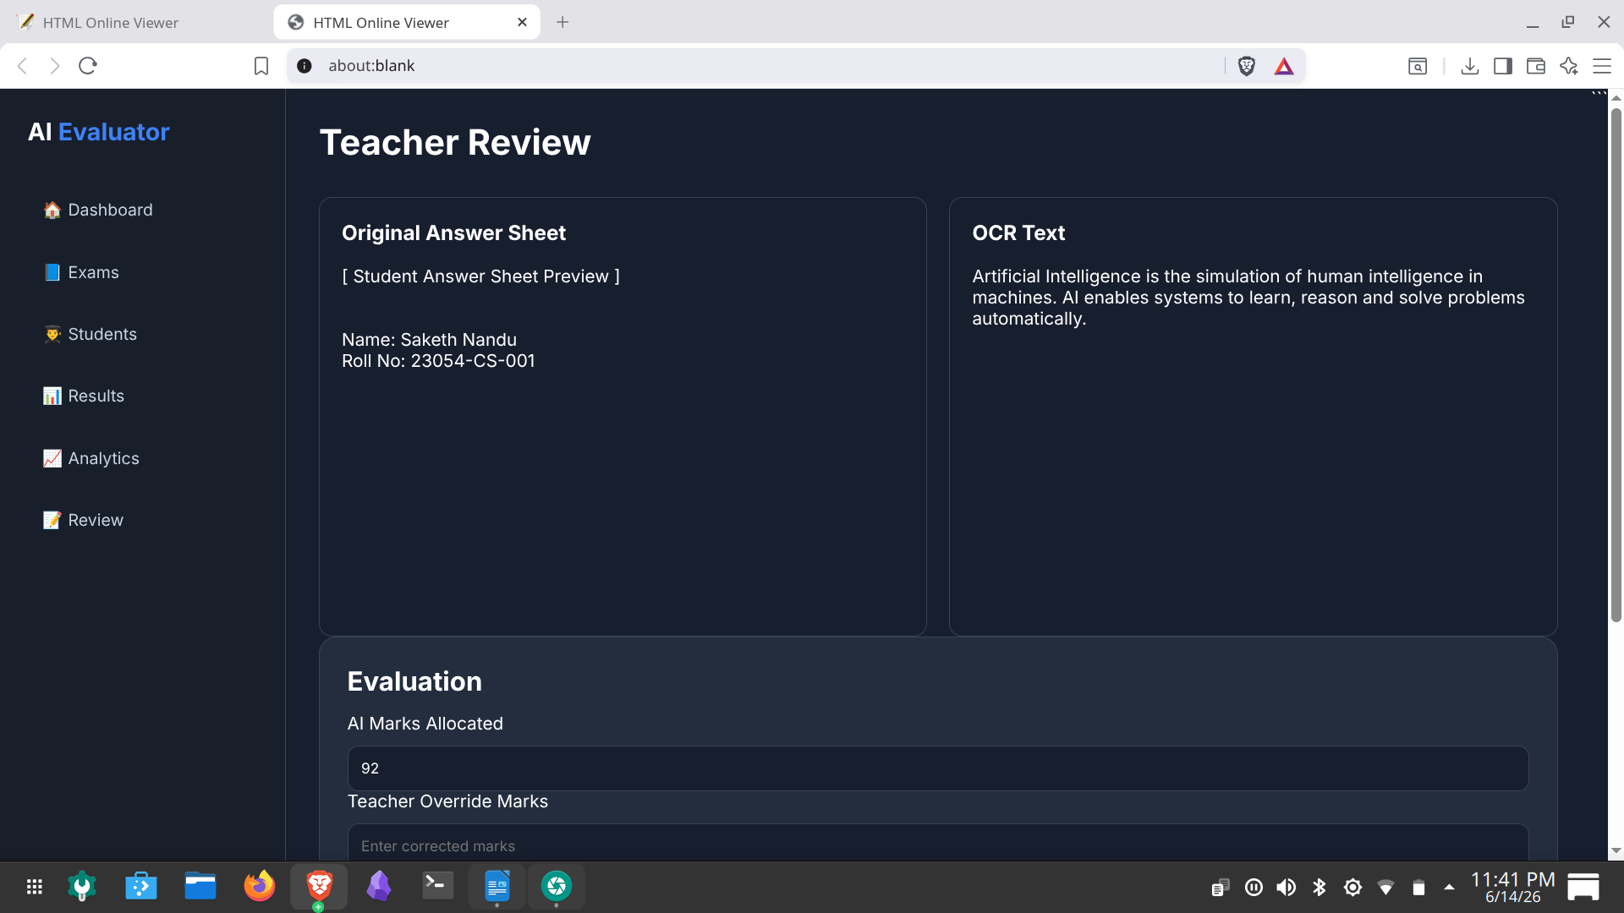

Analytics Output
The analytics dashboard provides visual insights into examination performance.
The output includes:
• Average Marks
• Highest Marks
• Lowest Marks
• Pass Percentage
• Student Performance Distribution
• Question-wise Analysis
These analytical outputs help teachers identify student strengths, weaknesses, and difficult examination questions.
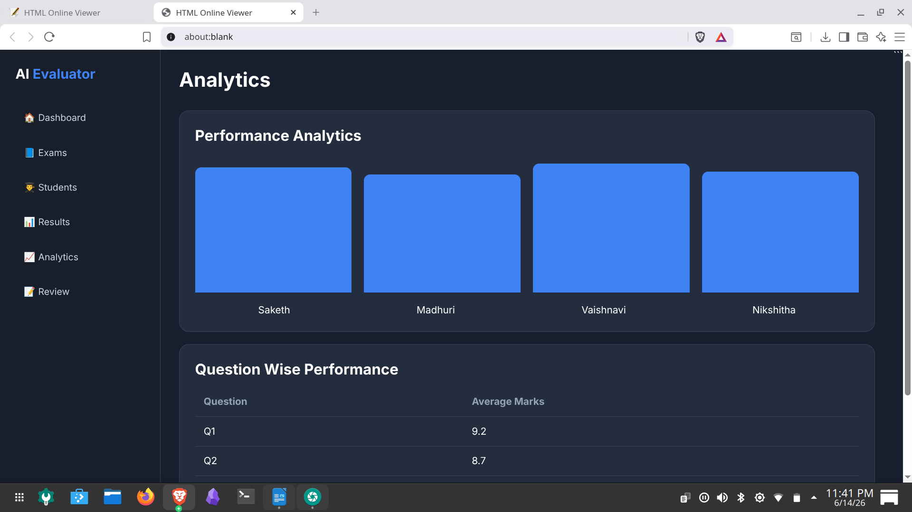
Output:
The generated outputs demonstrate the successful integration of OCR technology, Artificial Intelligence, and cloud services for automated examination evaluation and performance analysis.

CHAPTER-VIII
CONCLUSION

8.1 Summary of the Project
AI Hard Copy Exam Evaluator successfully demonstrates the application of Artificial Intelligence, Optical Character Recognition (OCR), and Large Language Models (LLMs) for automated evaluation of handwritten answer sheets. The system provides intelligent answer assessment capabilities, automated question-answer matching, confidence-based grading, teacher review functionality, and detailed report generation.
The platform combines Pabbly OCR API for handwritten text extraction and NVIDIA Nemotron Nano 12B Multimodal LLM for answer understanding and evaluation. By integrating AWS cloud services, the system offers a scalable and efficient solution for educational institutions seeking to automate examination assessment processes while maintaining transparency and accuracy.

8.2 Achievements and Findings

Key Achievements
- Developed a complete AI-powered examination evaluation platform for handwritten answer sheets.
- Successfully integrated Pabbly OCR API for extracting handwritten and printed text from uploaded answer sheets.
- Implemented automatic question extraction and question-answer matching mechanisms.
- Integrated NVIDIA Nemotron Nano 12B Multimodal LLM for intelligent answer evaluation and feedback generation.
- Developed confidence scoring to identify evaluation reliability.
- Created a teacher review and manual override system to improve transparency and control.
- Implemented detailed student performance reports and analytics dashboards.
- Utilized AWS EC2 for hosting, AWS S3 for storage, and AWS IAM for secure access management.
- Designed a modern web-based interface for examination management and evaluation monitoring.

Key Findings
- OCR technology significantly reduces manual data entry efforts during answer sheet evaluation.
- Semantic evaluation using Large Language Models provides more accurate assessment than traditional keyword-based grading methods.
- Confidence scoring helps identify answers requiring manual review.
- Combining AI evaluation with teacher supervision improves both efficiency and reliability.
- Cloud-based infrastructure enables scalable processing of large numbers of answer sheets.
- Automated report generation reduces administrative workload and accelerates result publication.

8.3 Future Enhancements

Potential Improvements
- Multi-Language Evaluation: Support answer sheets written in Telugu, Hindi, Tamil, Kannada, and other regional languages.
- Diagram Evaluation: Enable assessment of diagrams, flowcharts, and graphical representations using computer vision techniques.
- Mathematical Expression Evaluation: Support automatic checking of equations, derivations, and numerical problem-solving answers.
- Mobile Application: Develop Android and iOS applications for teachers and administrators.
- Advanced Analytics: Provide deeper insights into student performance trends and examination statistics.
- Learning Recommendations: Generate personalized suggestions for students based on strengths and weaknesses identified during evaluation.
- Real-Time Processing: Improve evaluation speed through parallel processing and optimized cloud deployment.
- LMS Integration: Integrate with Learning Management Systems and educational platforms for seamless examination workflows.
- Voice-Based Accessibility: Introduce voice-enabled features for improved accessibility and usability.

8.4 Final Thoughts
AI Hard Copy Exam Evaluator represents a significant step toward modernizing traditional examination assessment methods through Artificial Intelligence and cloud computing technologies. The project successfully demonstrates how OCR, Large Language Models, and intelligent evaluation techniques can be combined to automate complex educational workflows.
The integration of Pabbly OCR API and NVIDIA Nemotron Nano 12B Multimodal LLM enables the platform to understand, evaluate, and provide meaningful feedback on handwritten student responses. The inclusion of teacher review functionality ensures transparency and trust in AI-generated evaluations.
The successful implementation of this project demonstrates the practical applicability of Artificial Intelligence in educational technology. By reducing evaluation time, improving grading consistency, and providing detailed performance insights, the system contributes toward creating more efficient, scalable, and intelligent examination management solutions for educational institutions.

REFERENCES

9.1 Websites and Documentation
• FastAPI Documentation: https://fastapi.tiangolo.com/
• Python Documentation: https://docs.python.org/3/
• Pabbly OCR Documentation: https://www.pabbly.com/
• NVIDIA Nemotron Documentation: https://build.nvidia.com/
• Amazon EC2 Documentation: https://docs.aws.amazon.com/ec2/
• Amazon S3 Documentation: https://docs.aws.amazon.com/s3/
• AWS IAM Documentation: https://docs.aws.amazon.com/iam/
• HTML Documentation: https://developer.mozilla.org/en-US/docs/Web/HTML
• CSS Documentation: https://developer.mozilla.org/en-US/docs/Web/CSS
• JavaScript Documentation: https://developer.mozilla.org/en-US/docs/Web/JavaScript
• Uvicorn Documentation: https://www.uvicorn.org/
• Git Documentation: https://git-scm.com/doc
• GitHub Documentation: https://docs.github.com/
• AWS Documentation: https://docs.aws.amazon.com/

